Kubernetes Task

Task Description:

Setup minikube at your local and explore creating namespaces (Go through official documentation).

Install Docker

Install Minikube
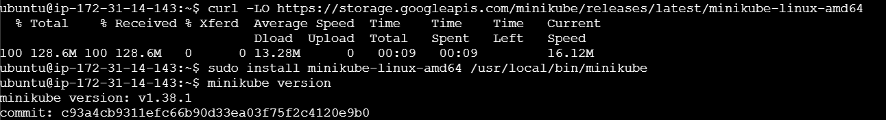

Install Kubectl
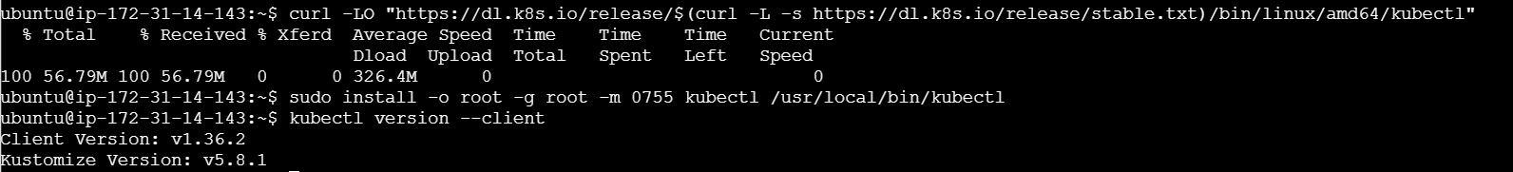

Start Minikube
sudo usermod -aG docker $USER
newgrp docker
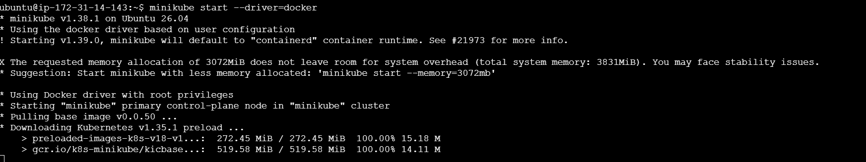
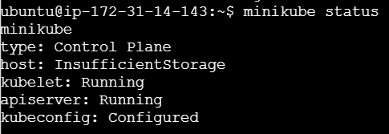
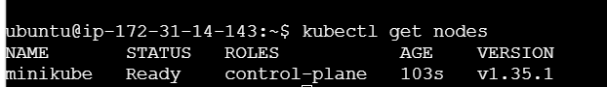

Create namespace
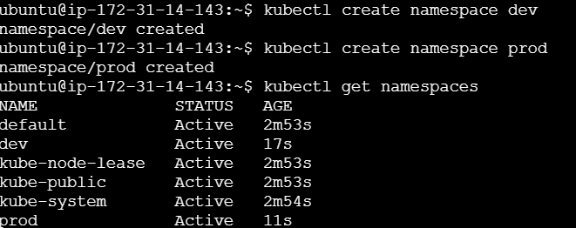

Delete minikube
